**Acoustic Sensor - Siren**

In this setting, a siren whistle is located inside a tube in an anechoic room. A fan is generating airflow in the tube due to which siren generates sound. This fan can rotate in 8 different speeds which are referred to as fan position 1 to 8. Depending on the fan speed, siren generates a different sound with specific characteristics. The sound is recorded and analyzed in order to find a relation between the sound and the speed of the fan. The next section, discusses how sounds are mapped to fan speeds based on their frequency components.

**Spectral components of acoustic signals**

In order to analyze the signals’ spectral components, a conversion from time domain to frequency domain is needed. The recorded sounds are about 10-30 seconds long with the sampling rate of 48000 sample/sec. Short-time Fourier Transform (STFT) is applied to the signals to obtain their frequency components in different time frames. STFT parameters are chosen as below:

Window: blackman

Window size: 14400 (corresponding to 300 milliseconds)

Overlap percentage: 50%

FFT size (N) = 16384

$$Frequency resolution= \frac{f_{s}}{N}=2.9297 Hz$$

The magnitude spectrum of signals is used to analyze the signal and estimate the fan speed.

The recorded audio sound comprises siren’s whistling sound, sound caused by the rotating fan (fan noise) and artifacts created because of reflection of sound waves hitting the walls of the tube. So, the recorded audio signal is not a pure whistle sound.

In another recording the whistle is removed, and the sound generated by the fan is only recorded. The magnitude spectrum obtained for this audio signal for one time frame is shown below.

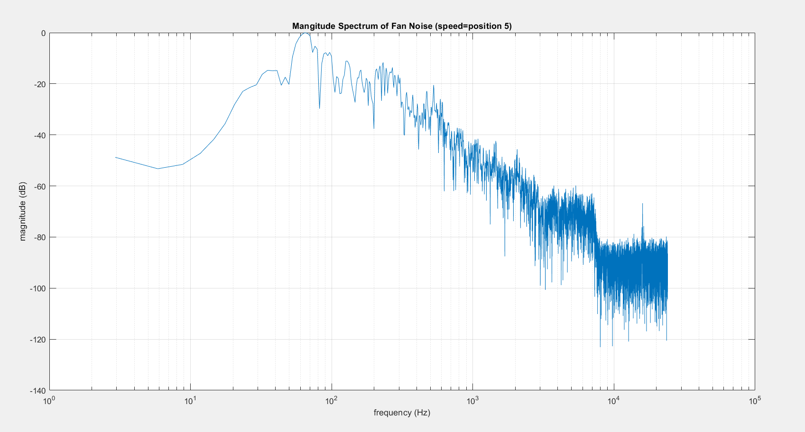

Figure : magnitude spectrum of noise caused by the fan, rotating at fan position 5.

As shown in the spectral magnitude plot, most of the noise spectral components belong to low frequencies.

Figure below shows the magnitude spectrum corresponding to one time frame of the recorded whistle signal which includes the whistle sound plus fan noise.

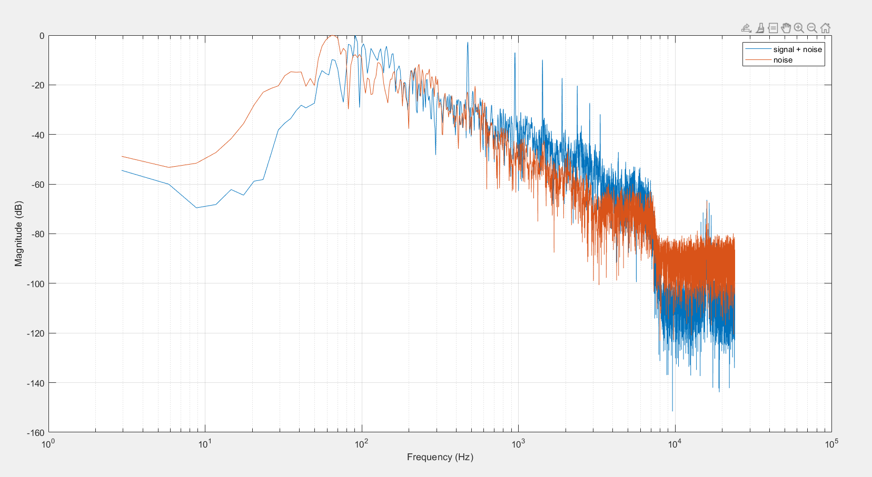

Figure : magnitude spectrums of signals 1) whistle plus fan noise, 2) fan noise, rotating at fan position 5.

As it can be seen, SNR is really low in low frequencies and distinguishing the main signal peaks from peaks that happen due to fan noise is impossible. In order to mitigate the noise effect in frequency spectrum, magnitude spectrum of multiple time frames is averaged (Welch’s method). By doing this, the variability of noise is reduced.

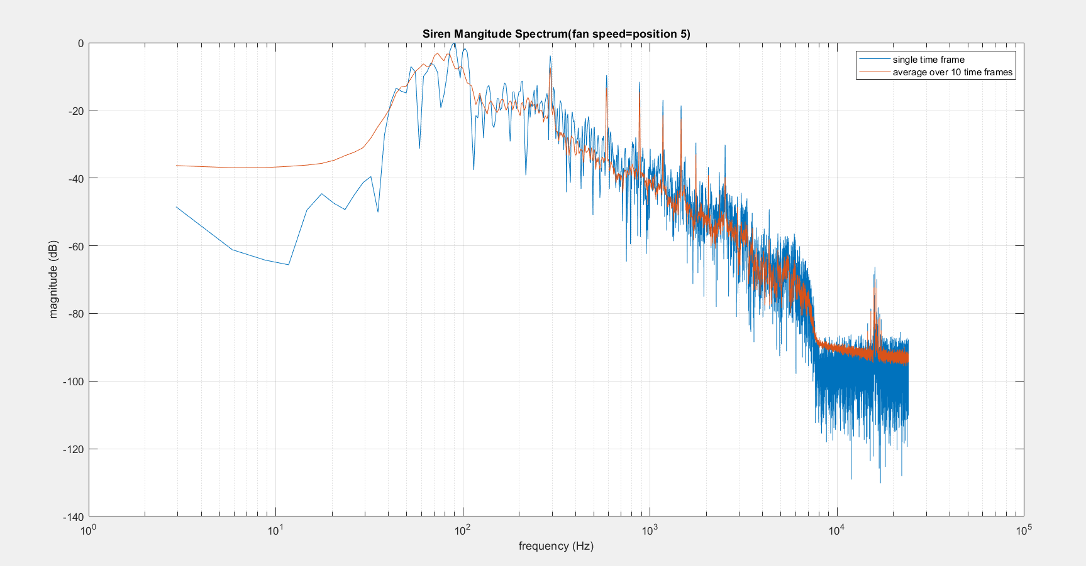

Signals produced by siren are harmonic signals. They consist of a fundamental frequency and its multiples (harmonics). Depending on the fan speed, the fundamental frequency varies. Two-way mismatch algorithm is used on averaged magnitude spectrums to detect the signal’s fundamental frequency. Every 10 time frames’ magnitude spectrums are averaged and represented as a single magnitude spectrum.

The airflow is measured for all the 8 positions of the fan by an anemometer for approximately 1 minute. The values meansured by the anemometer for a specific fan position is averaged. As a result, data points are obtained in the format (fundamental frequency, airflow speed) = (f0,v).

A linear model is fit to the data that maps fundamental frequencies to airflow speed.

